Indoor Humidity Regulation System Using DEVS
Bahareh Pourahmad
SYSC 5104 / SYSC 4906G

Abstract
This project develops a hierarchical Discrete-Event System Specification (DEVS) model for regulating indoor relative humidity (RH) around a reference value of 45%. Indoor humidity evolves due to leakage-driven exchange with outdoor air and moisture injection from an on/off humidifier. A hysteresis-based controller is used to prevent excessive switching and ensure stable operation. The model is implemented in C++ using the Cadmium simulator and validated through simulation experiments. Results demonstrate stable and bounded behavior under dry outdoor conditions.

Part I: Conceptual Model and System Description
1. Introduction
Indoor relative humidity (RH) is an important environmental parameter that affects comfort, health, and building integrity. External disturbances, particularly dry outdoor air, continuously influence indoor conditions and drive RH away from desired levels.
To regulate humidity effectively, a control system is required. In this project, a DEVS-based model is developed to capture the event-driven dynamics of humidity control and system interactions.

2. System Overview
The system consists of three main components:
- IndoorAir
- LeakageEstimator
- HumidityPlant
These components interact through a feedback loop.

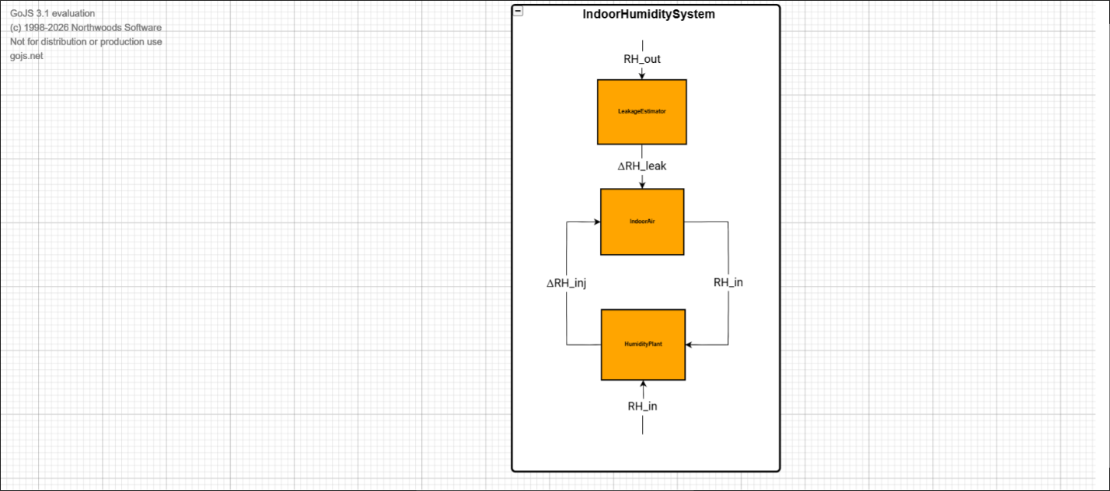
Figure 1: IndoorHumiditySystem Coupled Model
Figure 1 illustrates the overall system structure. The LeakageEstimator models environmental disturbances and provides a humidity loss signal to the IndoorAir component. The IndoorAir outputs the current RH, which is fed to the HumidityPlant. The HumidityPlant computes the control action and injects moisture back into the IndoorAir, forming a closed-loop system.

3. HumidityPlant Subsystem
The HumidityPlant consists of:
- Humistat (controller)
- Humidifier (actuator)

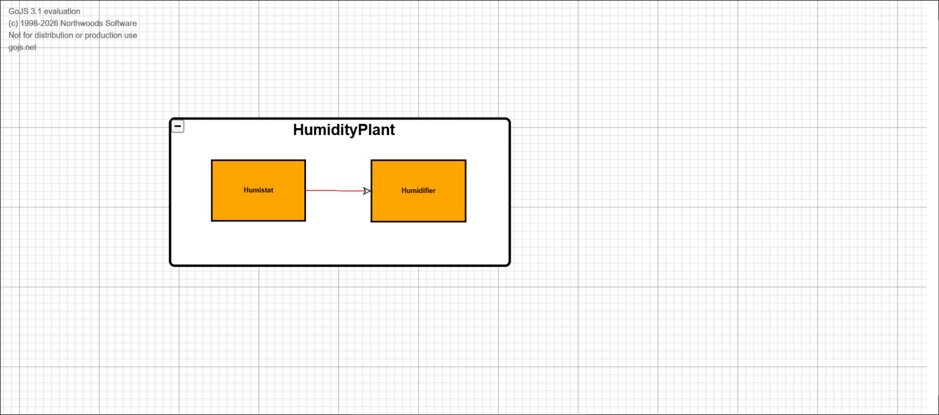
Figure 2: HumidityPlant Structure
Figure 2 shows the internal structure of the control subsystem. The Humistat evaluates the indoor RH and determines whether the humidifier should be ON or OFF. The Humidifier injects moisture into the IndoorAir when activated.

4. Control Strategy (Hysteresis)
The controller uses hysteresis logic:
- ON when RH < 43%
- OFF when RH > 47%

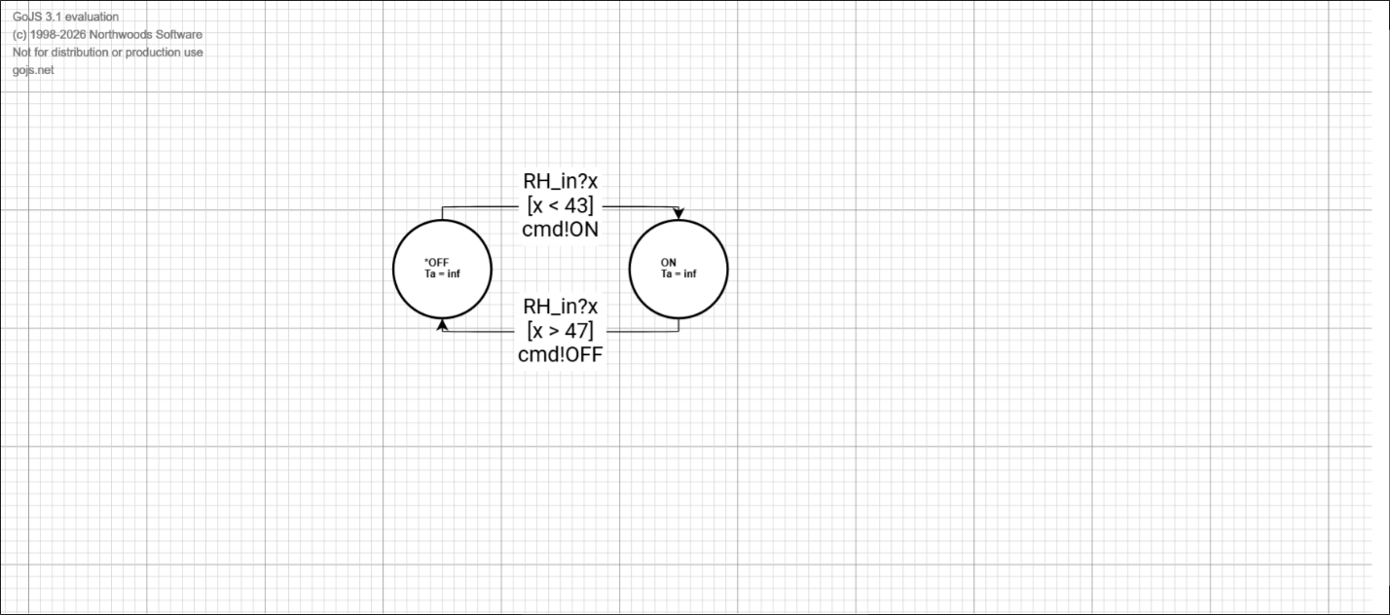
Figure 3: Humistat Finite State Machine
Figure 3 illustrates the state transitions of the Humistat. The system switches between ON and OFF states depending on the RH value. The hysteresis band prevents rapid switching and ensures stable system behavior.

Part II: DEVS Formalization and Experimental Frame
1. DEVS Formalism
- Each atomic model is defined as:
- M = < X, S, Y, δint, δext, λ, ta >
Where:
- X: input
- S: state
- Y: output
- δint: internal transition function
- δext: external transition function
- λ: output function
- ta: time advance
2. Formal Specification of Atomic Models
- In this section, each atomic component of the system is formally defined using the DEVS formalism.

- 2.1 IndoorAir Model
- The IndoorAir model represents the evolution of indoor relative humidity.
- State (S):
Current indoor relative humidity $RH$
- Input (X):
- $ΔRH_{leak}$: humidity loss from leakage
- $ΔRH_{inj}$: humidity injection from humidifier
- Output (Y):
- Current indoor humidity $RH$
- Internal Transition ($δ_{int}$):
Updates humidity based on internal dynamics.
- External Transition ($δ_{ext}$):
When receiving inputs:
- $RH←RH+ΔRH_{inj}-ΔRH_{leak}$
- Output Function ($λ$):
Outputs updated humidity value.
- Time Advance (ta):
Constant or event-driven step.

- 2.2 LeakageEstimator Model
- This model represents the effect of environmental disturbance.
- State (S):
Leakage rate or constant disturbance value
- Input (X):
Outdoor humidity condition
- Output (Y):
- $ΔRH_{leak}$
- External Transition ($δ_{ext}$):
Updates leakage effect based on outdoor conditions
- Output Function ($λ$):
Generates humidity loss signal
- Time Advance (ta):
Periodic or constant

- 2.3 Humistat Model
- The Humistat implements hysteresis control.
- State (S):
{ON, OFF}
- Input (X):
Indoor humidity $RH$
- Output (Y):
Command signal (ON/OFF)
- External Transition ($δ_{ext}$):
- if RH < 43 → state = ON
if RH > 47 → state = OFF
- Output Function ($λ$):
Outputs control command (ON or OFF)
- Time Advance (ta):
∞ (event-driven)

- 2.4 Humidifier Model
- The Humidifier injects moisture based on control input.
- State (S):
{ON, OFF}
- Input (X):
Control command from Humistat
- Output (Y):
- $ΔRH_{inj}$
- External Transition ($δ_{ext}$):
Updates state based on control input
- Output Function ($λ$):
- if ON → output ΔRH_inj > 0
if OFF → output ΔRH_inj = 0
- Time Advance (ta):
Constant

3. Atomic Models
- IndoorAir updates RH based on leakage and injection
- LeakageEstimator generates disturbance
- Humistat makes control decisions
- Humidifier injects moisture

4. Coupled Model
The system forms a closed-loop structure where:
- disturbance affects IndoorAir
- controller reacts
- actuator corrects RH

5. Experimental Frame
- EF1: Validate controller behavior
- EF2: Validate full system response

The experimental framework follows a hierarchical validation approach.

First, atomic models were tested individually to verify correct behavior.
For example, the Humistat model was tested using different RH inputs to ensure
correct switching between ON and OFF states according to the hysteresis thresholds.

Second, coupled subsystems were tested to verify correct interaction between
components, particularly between the Humistat and Humidifier.

Finally, the full IndoorHumiditySystem was simulated under dry outdoor conditions.
The results presented in Figure 4 correspond to this integrated system test.

This incremental testing approach ensures correctness at each level of the model hierarchy.
Part III: Simulation Results and Discussion
1. Simulation Setup
- Initial RH ≈ 50%
- Reference RH = 45%
- Dry outdoor condition

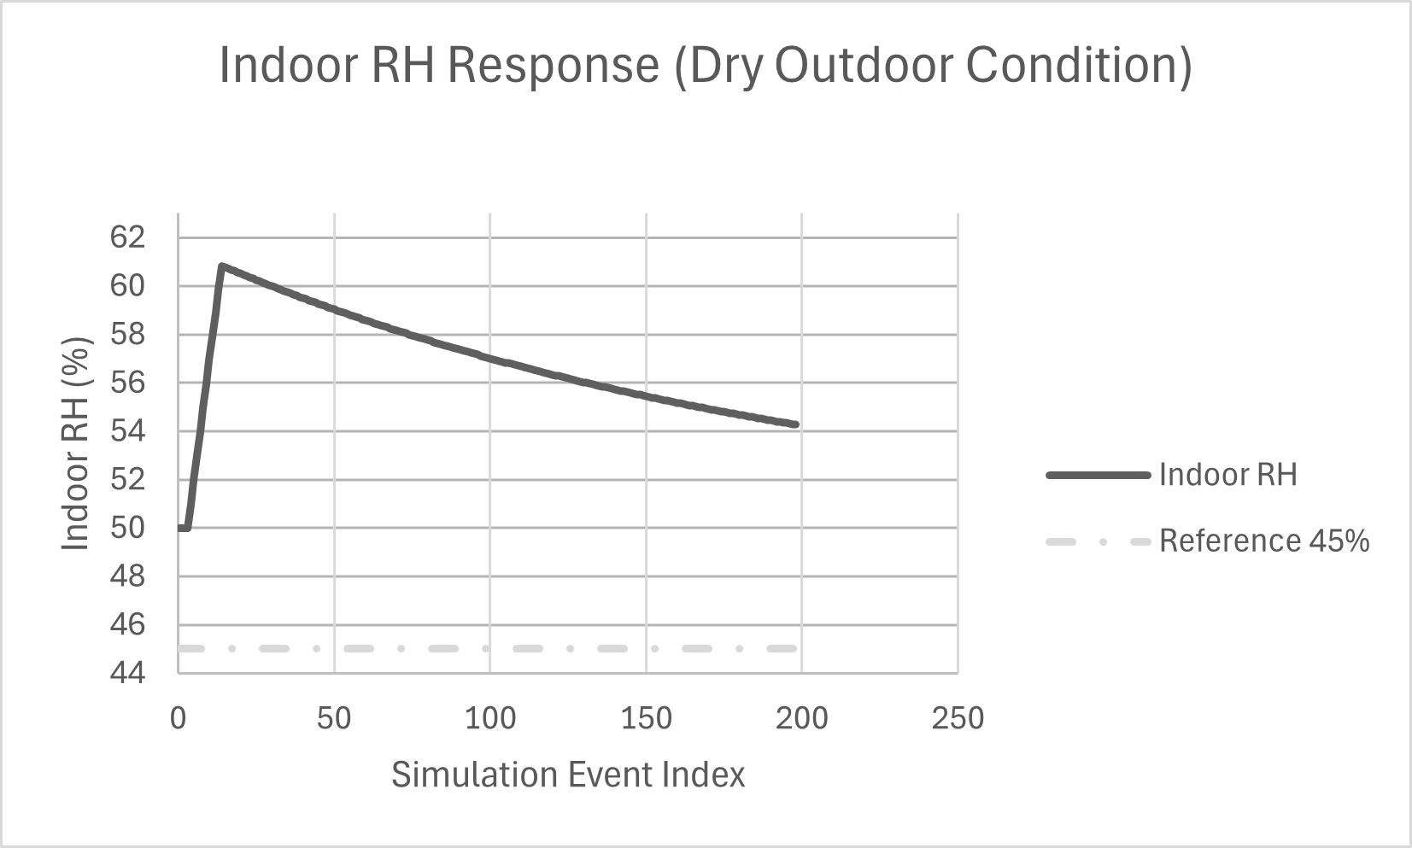
Figure 4: Indoor RH Response (Dry Outdoor Condition)
Figure 4 shows the evolution of indoor relative humidity over the simulation.
The dashed line represents the reference value of 45%, while the solid curve
represents the system response. The figure clearly illustrates the initial
overshoot, followed by gradual decay and stabilization above the reference value.

2. System Behavior Analysis
Phase 1: Initial Condition
RH starts above the reference value (~50%), and the humidifier is OFF.

Phase 2: Rapid Increase
The humidifier activates, causing RH to increase rapidly to approximately 61%.
Reason:
- discrete-event control delay
- strong injection

Phase 3: Gradual Decrease
After reaching the peak, the humidifier turns OFF and leakage dominates.
RH decreases gradually.

Phase 4: Stabilization
The system stabilizes around 53–55%, above the reference value.

3. Interpretation
Stable behavior
The system remains bounded and does not diverge
Hysteresis effect
Prevents rapid switching but introduces oscillation
Steady-state offset
Occurs because leakage and injection are not perfectly balanced
Overshoot
Caused by delayed control response

4. Engineering Insights
- Hysteresis improves stability but reduces precision
- Leakage determines equilibrium
- Control tuning is important

Conclusion
The DEVS-based indoor humidity regulation system successfully demonstrates stable and realistic behavior under disturbance conditions. The hysteresis controller prevents excessive switching while maintaining bounded humidity levels. The results validate the effectiveness of event-driven modeling for control applications.

